**TYRE STUDY**

# GUI interface

The data from the TTC (Tire Test Consortium) are studied thanks to a GUI interface:

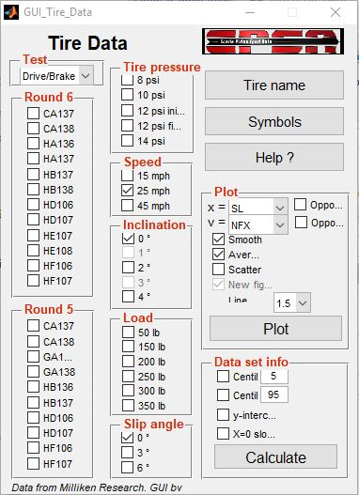

Figure 2: 2D model to determine front suspension geometry

Figure 3: Motion ratios of the car

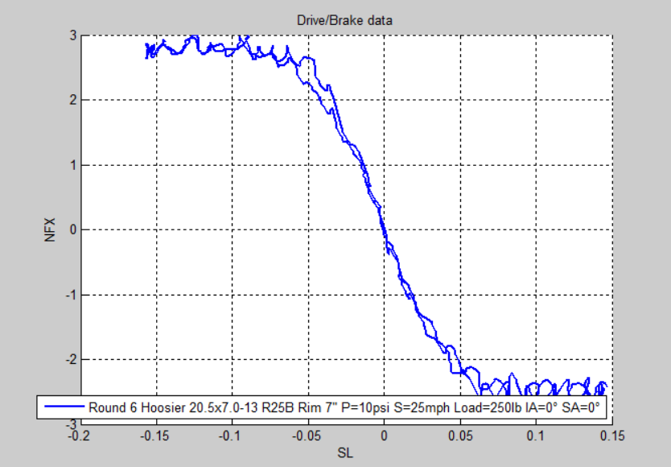

Figure 1: GUI interface

Figure 2-a: Data obtained

Figure 4: 3D model used to confirm the motion ratio curves

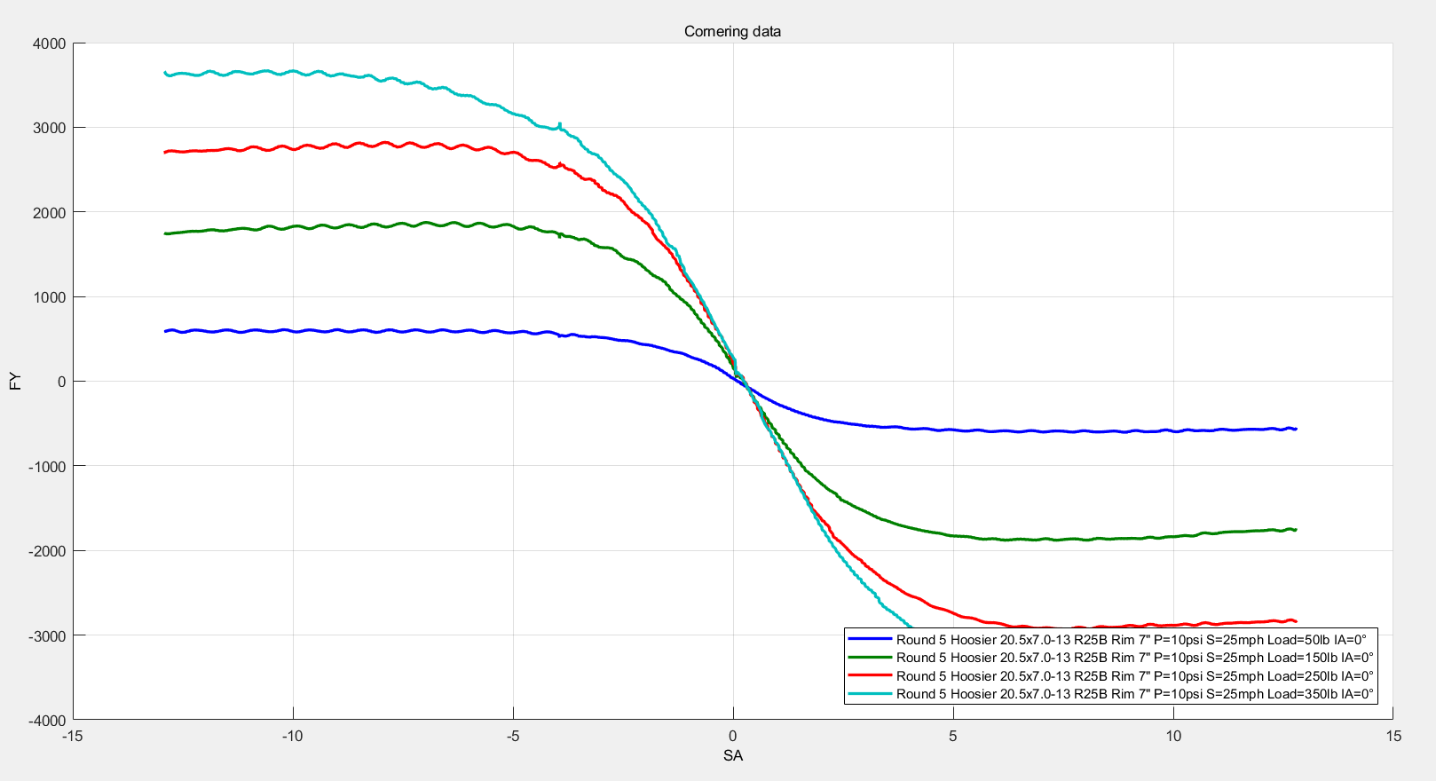

Figure 2-b: Data obtained

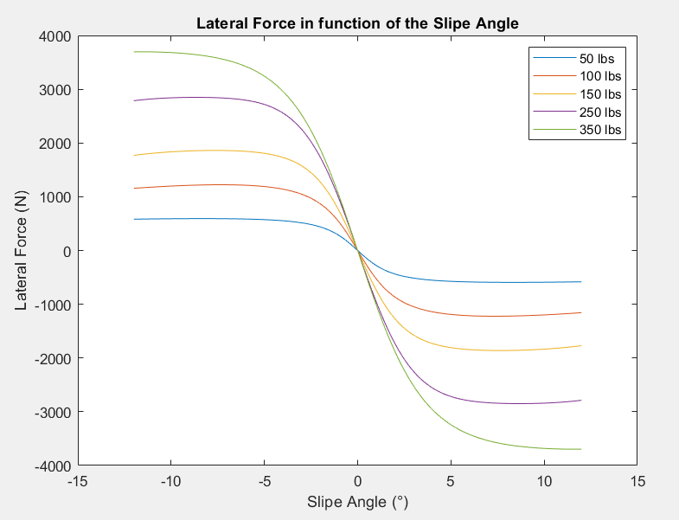

Figure 3: Data treatment with 94” Pacejka formula for easier use of data